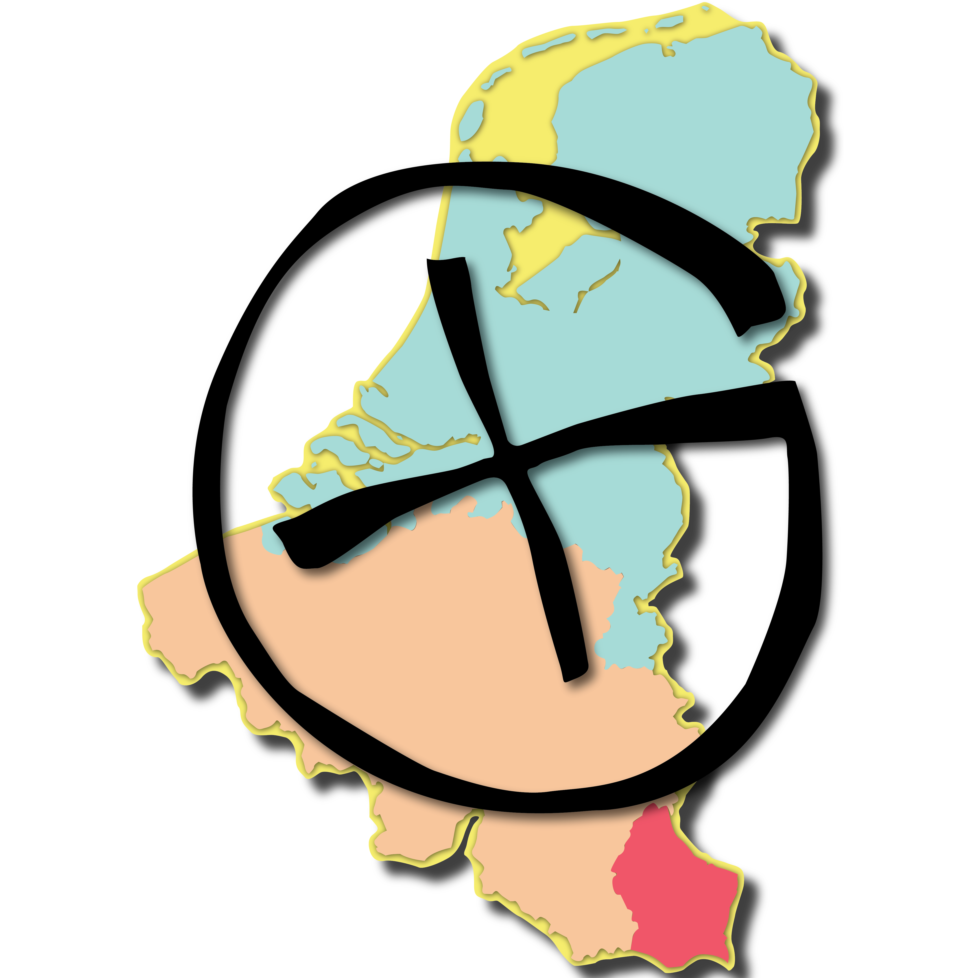

Congratulations!
You’ve found a geocache!

Geocaching is an outdoor sport or activity in which finders (or cachers as they are known) use a GPS receiver to find a "treasure" hidden by other participants.

If you have found
this container by accident:
Please feel free to write about it in the log book and check out the online listing to let others know about it. While you’re there, why not see if there are other caches hidden near you?

Two rules:
-There may be small items contained in this geocache. If you see something you like, go ahead and take it, but leave something just as good for the next person to find!
-Please do not move or damage the container. Leaving the container concealed where you found it ensures that others will be able to enjoy finding it as well.

For more information, or to log your visit, please go to:

http://coord.eu/OBxxxx

Congratulations!
You’ve found a geocache!

Geocaching is an outdoor sport or activity in which finders (or cachers as they are known) use a GPS receiver to find a "treasure" hidden by other participants.

If you have found
this container by accident:
Please feel free to write about it in the log book and check out the online listing to let others know about it. While you’re there, why not see if there are other caches hidden near you?

Two rules:
-There may be small items contained in this geocache. If you see something you like, go ahead and take it, but leave something just as good for the next person to find!
-Please do not move or damage the container. Leaving the container concealed where you found it ensures that others will be able to enjoy finding it as well.

For more information, or to log your visit, please go to:

http://coord.eu/OBxxxx

Congratulations!
You’ve found a geocache!

Geocaching is an outdoor sport or activity in which finders (or cachers as they are known) use a GPS receiver to find a "treasure" hidden by other participants.

If you have found
this container by accident:
Please feel free to write about it in the log book and check out the online listing to let others know about it. While you’re there, why not see if there are other caches hidden near you?

Two rules:
-There may be small items contained in this geocache. If you see something you like, go ahead and take it, but leave something just as good for the next person to find!
-Please do not move or damage the container. Leaving the container concealed where you found it ensures that others will be able to enjoy finding it as well.

For more information, or to log your visit, please go to:

http://coord.eu/OBxxxx

